11/2023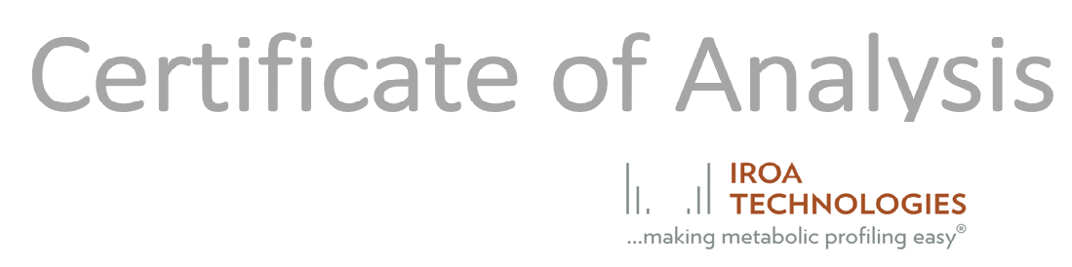

Product Name: Large Scale Metabolite Library of Standards
Product Number: LSMLS
Product Brand: IROA TECHNOLOGIES

TEST: SPECIFICATION
LOT 230-24 RESULTS
Please click here to obtain the associated Plate Map in PDF format.

